TASKS ON CLOUDFRONT AND ROUTE53

1. Configure VPC peering in cross regions.

PURPOSE: Cross region VPC peering allow two virtual private clouds (VPCs) located in different geographic regions to communicate with each other using private IP addresses, as if they were part of the same network.

OBJECTIVE: To configure cross-region VPC peering to enable secure, low-latency, and private communication between resources deployed in different regions.

PREREQUISITES:
- Two vpcs in different AWS regions.
- Non-overlapping CIDR ranges.
- An active peering request accepted by the peer VPC owner.
- Route table entries in both vpcs.
- Security group and NACL rules permitting the desired traffic.
OUTCOME: Successfully established VPC peering between VPCs, enabling secure and private communication over internal IP addresses, improving connectivity between application resources while avoiding public internet exposure and supporting scalable multi-region network architecture.
STEP BY STEP IMPLEMENTATION:

- First of all, make sure that 2 VPCs with different CIDR ranges are present in both regions.
- In the navigation pane, go to peering connections and there raise a peering connection with the target VPC ID of other region.
- After requesting the peering connection, go to target VPC region and go to the VPC pane in that VPC go to peering connection.
- There you get to see the request that made from the requestor VPC.
- Select that VPC and click on action, select accept the connection request.
- After accepting, update the route of both VPCs of both regions with CIDR ranges. So that accept the traffic coming from them.
- Now launch two EC2 instances in both VPCs and from the requestor region, you have ssh that EC2 instance and from there connect to EC2 instance of acceptors region with the private IP of instance.
- In CLI, you get to see the peering connectivity between these VPCs.

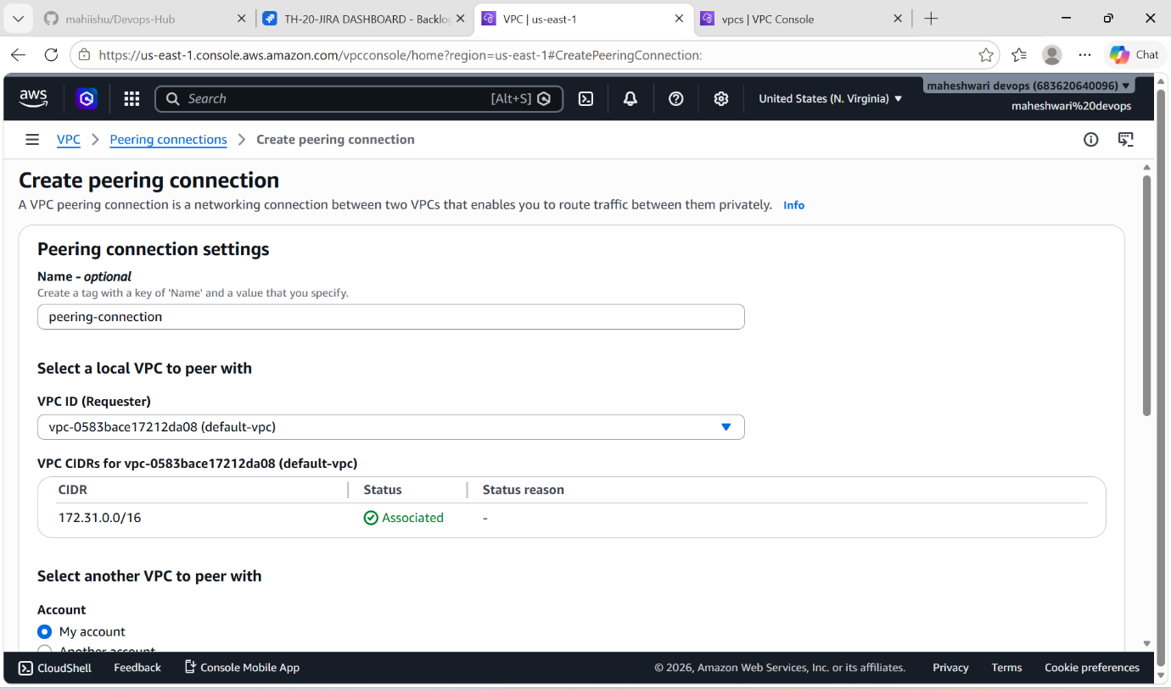

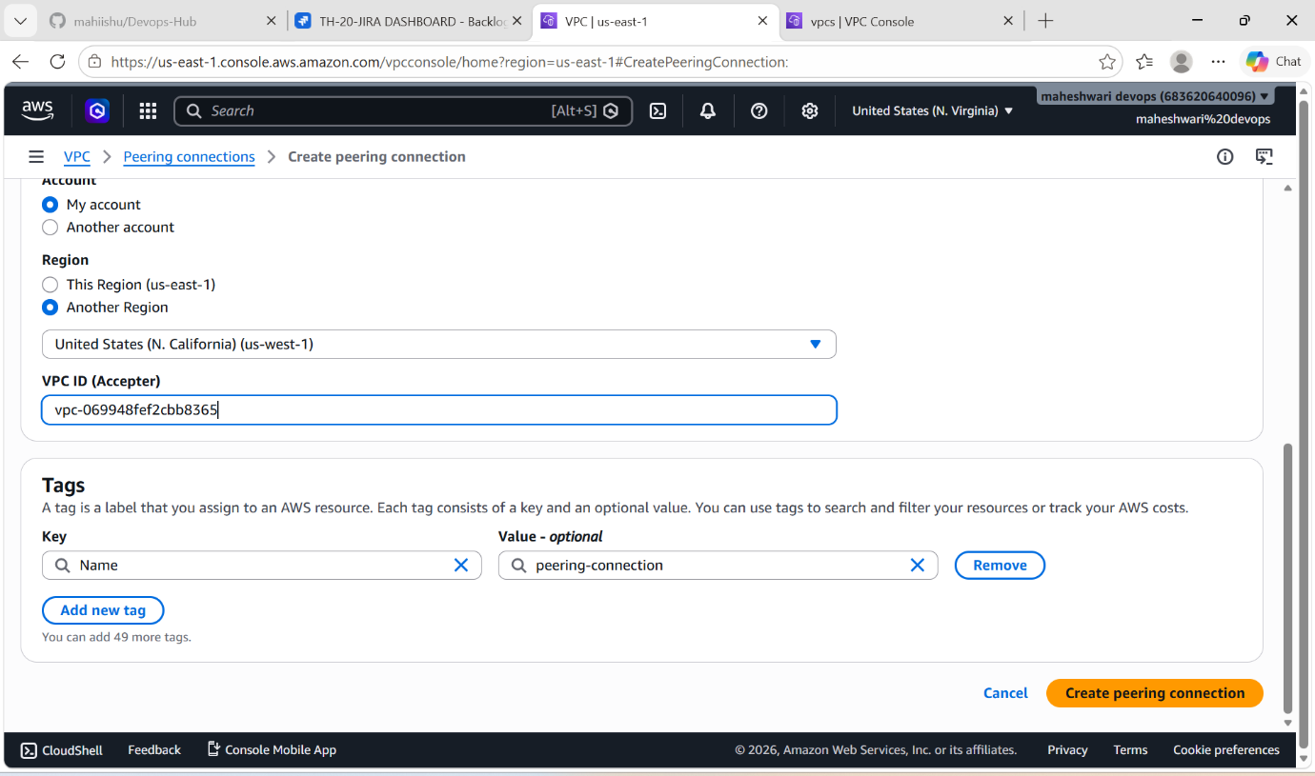

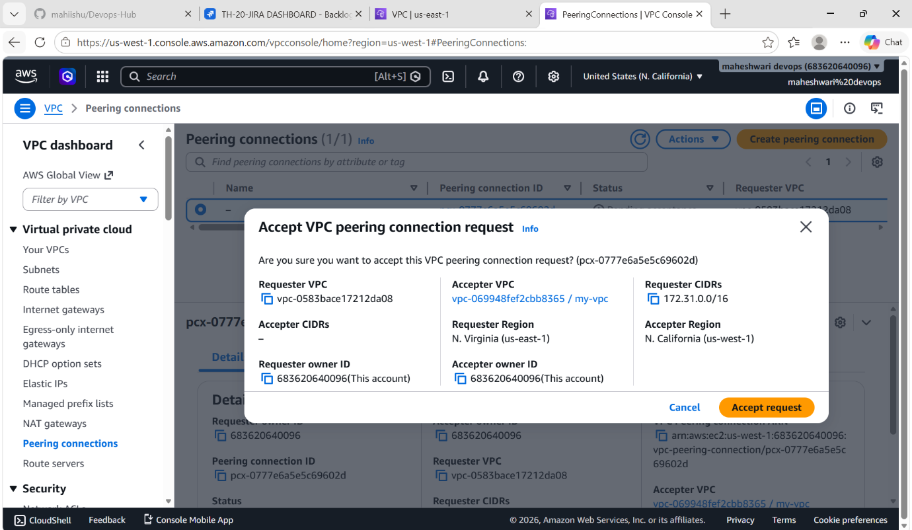

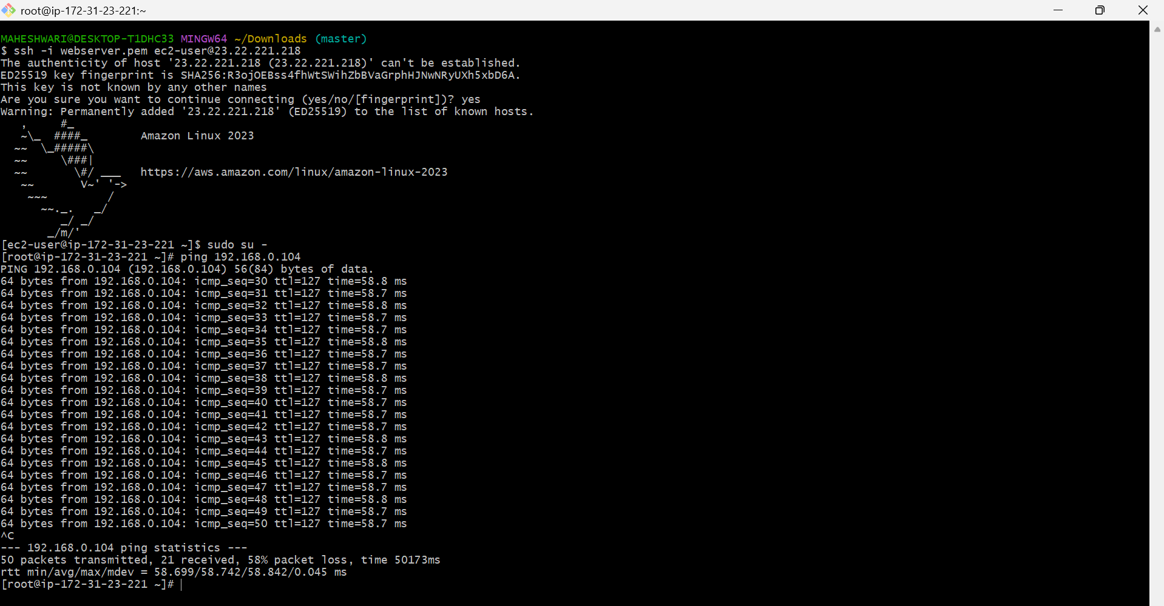

2. Purchase one domain from GoDaddy.

PURPOSE: The purpose of purchasing a domain from GoDaddy is to obtain a unique and professional internet address for a website, application or online service.

OBJECTIVE: To register and secure a unique domain name through GoDaddy for establishing an online presence, hosting a website, creating professional email addresses, and building a recognizable brand identity.

OUTCOME: Successfully registered a unique domain name through GoDaddy, establishing ownership of a web address that can be used for website hosting, professional email services and online brand identity.

STEP BY STEP IMPLEMENTATION:
- Go to the GoDaddy website and search the domain name that you want create.
- Then it will give some options line .in, .com,.online like this.
- Then after select which type domain you want click on add to cart.
- And then purchase that domain name.

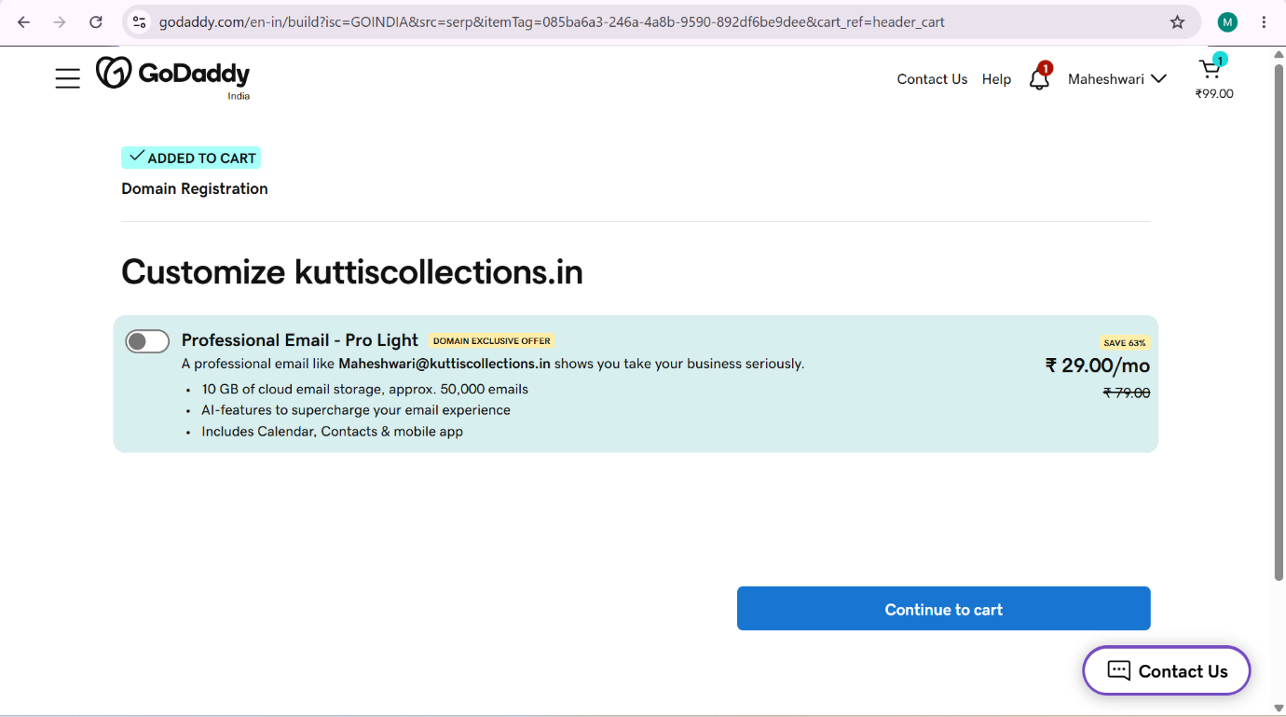

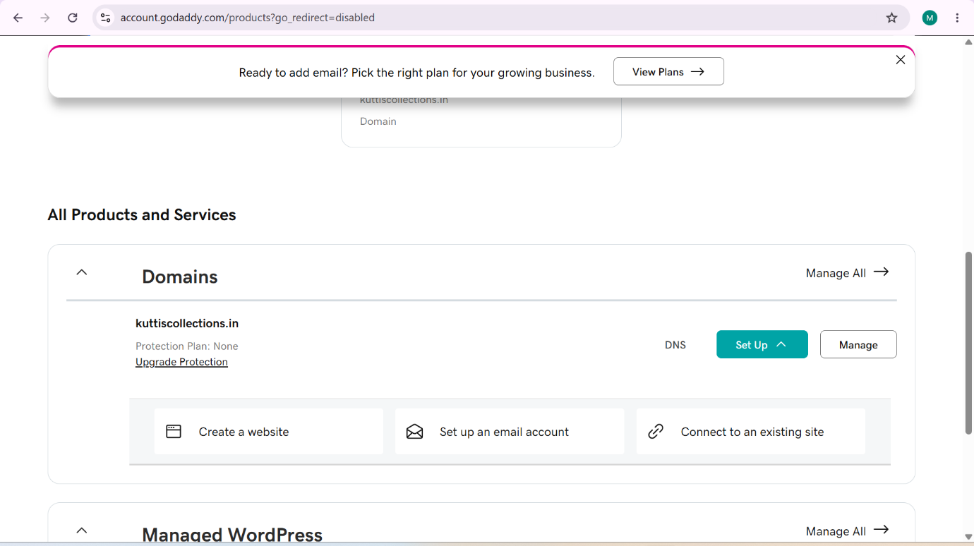

3. Deploy static website in S3.

PURPOSE: The purpose of deploying a static website in an S3 bucket is to host and serve web content such as HTML, CSS, JavaScript, Images and other static files directly from Amazon S3 without the need for a web server.

OBJECTIVE: To host and make a static website publicily accessible by configuring Amazon S3 static website hosting, uploading website files and setting the appropriate permissions and policies.

OUTCOME: A fully functional static website is successfully hosted on Amazon S3 and accessible to user through public website URL, demonstrating the use of AWS S3 for static web hosting.

STEP BY STEP IMPLEMENTATION:
- Go to properties of the S3 bucket and then when you scroll down you will get to see that host static website.
- That option you have to select and give the names of the files like index.html and error.html.
- Now add the objects of the static website and one more thing the names of objects should be match to file names that we have given to the static website host properties.
- After uploading, we can access that static website by the url that have created when we have enabled the host static website.
- That will be in properties pane of the S3 bucket.

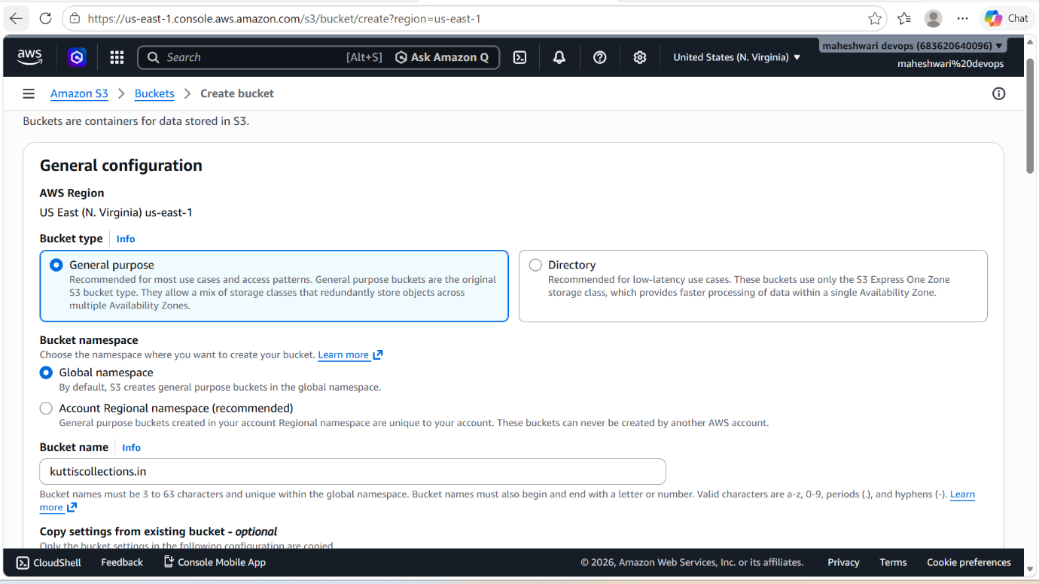

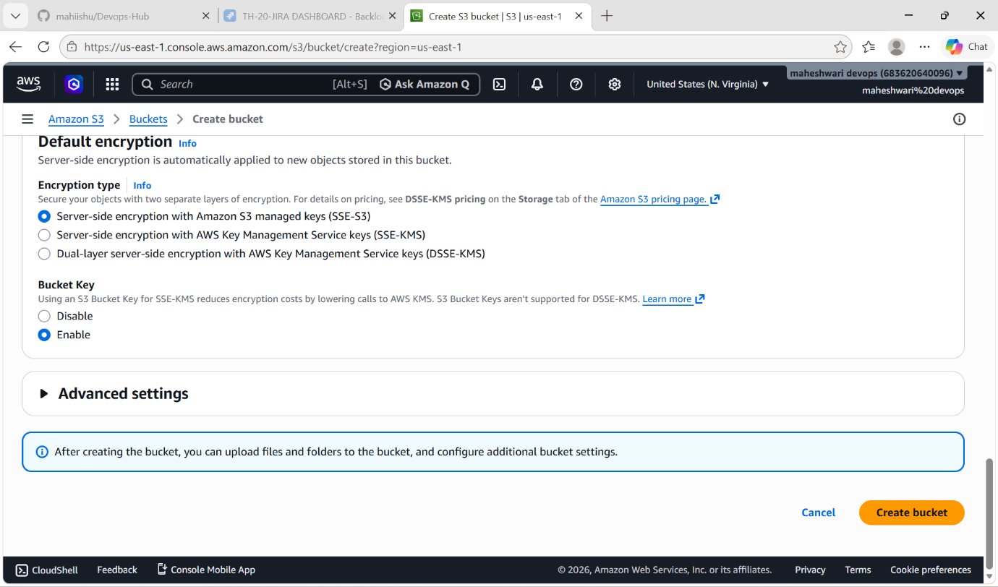

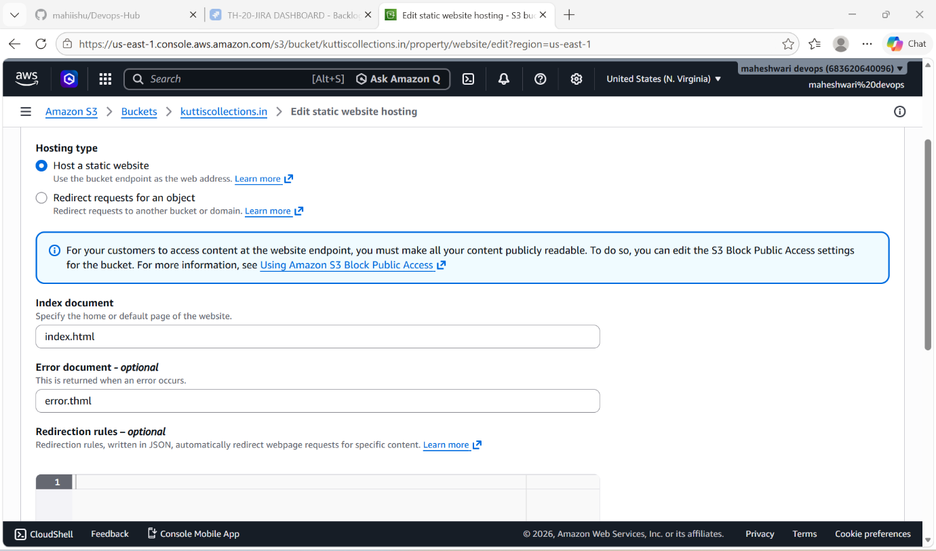

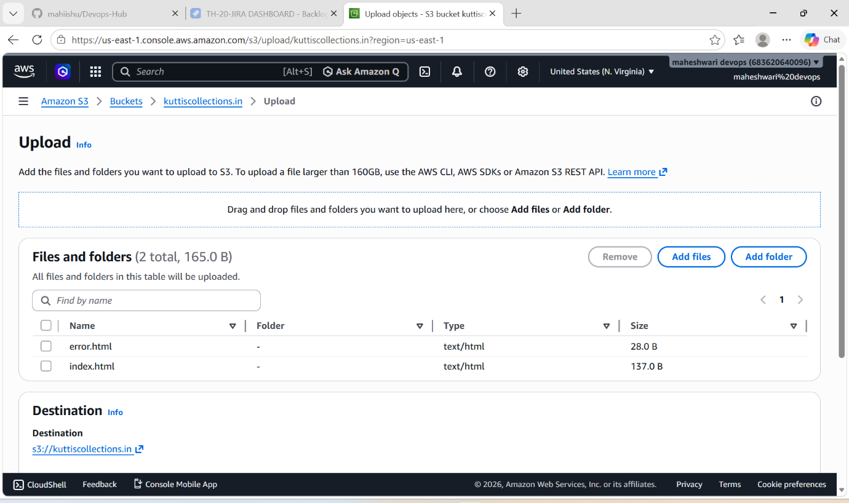

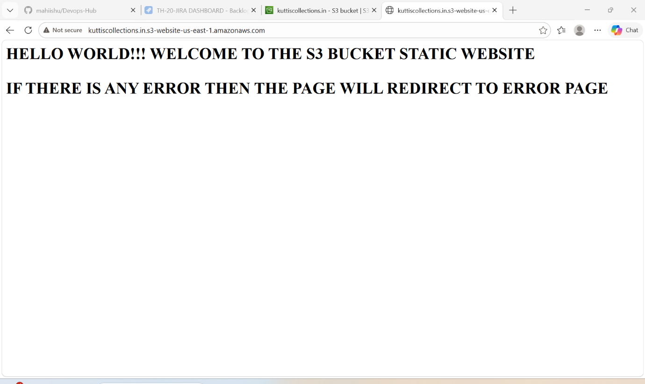

4. Create a CDN and attach one SSL certificate.

PURPOSE: To improve website performance, availability and security by distributing content through a content Delivery Network and enabling encrypted HTTPS communication using an SSL certificate.

OBJECTIVE: To configure a Content Delivery Network (CDN) to distribute web content efficiently across global edge locations and attach an SSL certificate to enable secure HTTPS communication, ensuring improved performance, reduced latency, and encrypted data transfer between users and the application.

OUTCOME: A CloudFront CDN distribution is created and ssl certificate is attached successfully.

STEP BY STEP IMPLEMENTATION:
- For creating an CDN, we have to request for a ssl certificate in Amazon Certificate Manager service in AWS.
- There create a new SSL certificate by clicking on a request certificate.

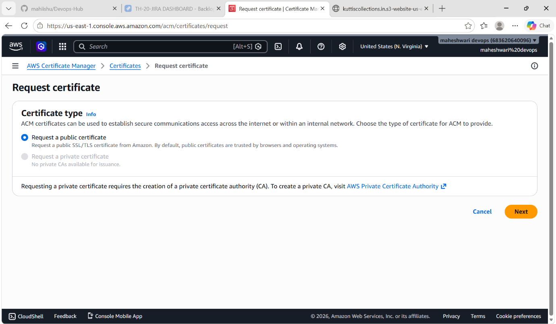

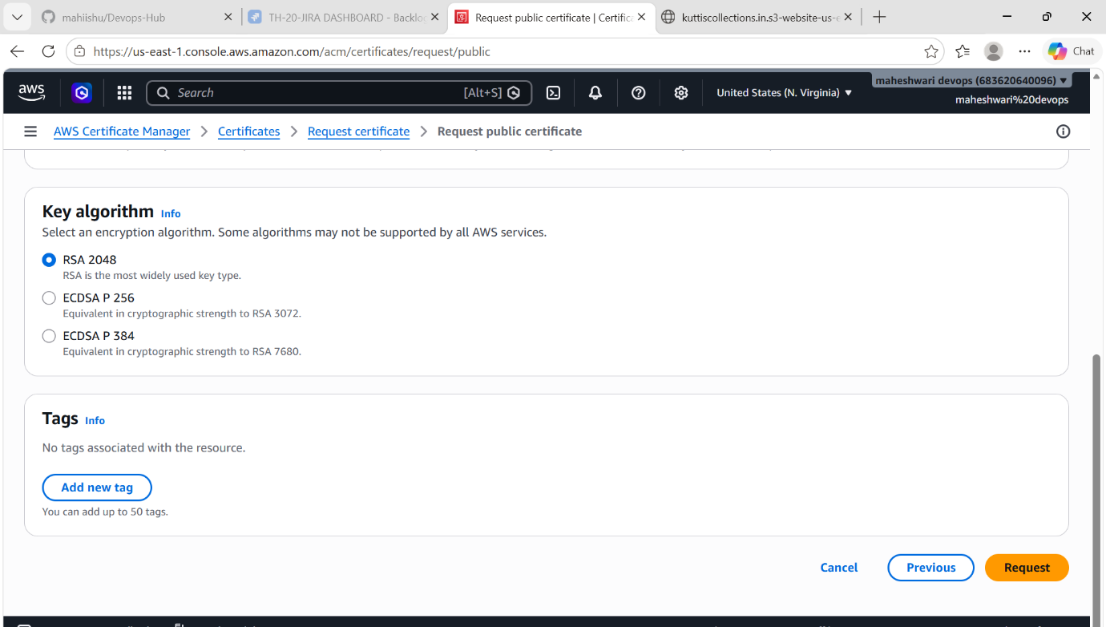

- Then go to CloudFront service in AWS, create a distribution.
- Then give the name of the domain of your that you have created.
- Then after click on create distribution.

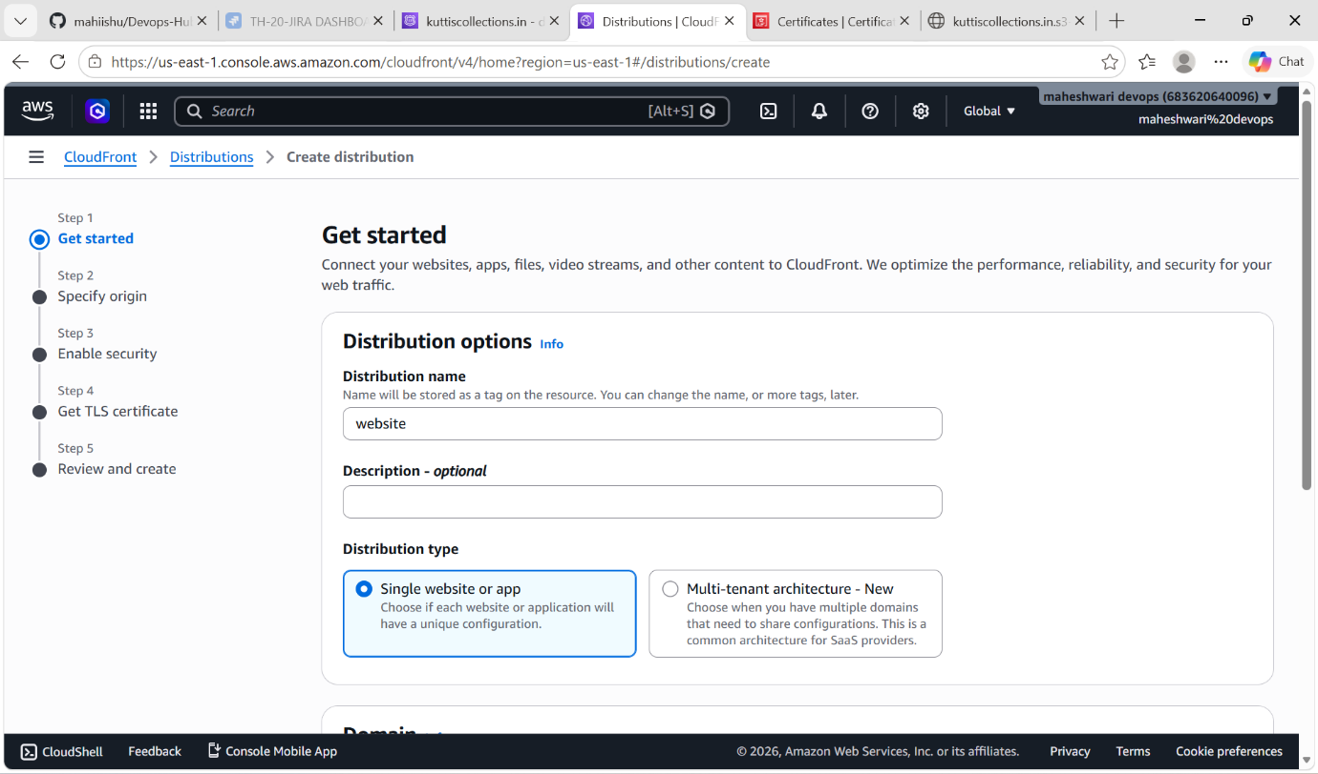

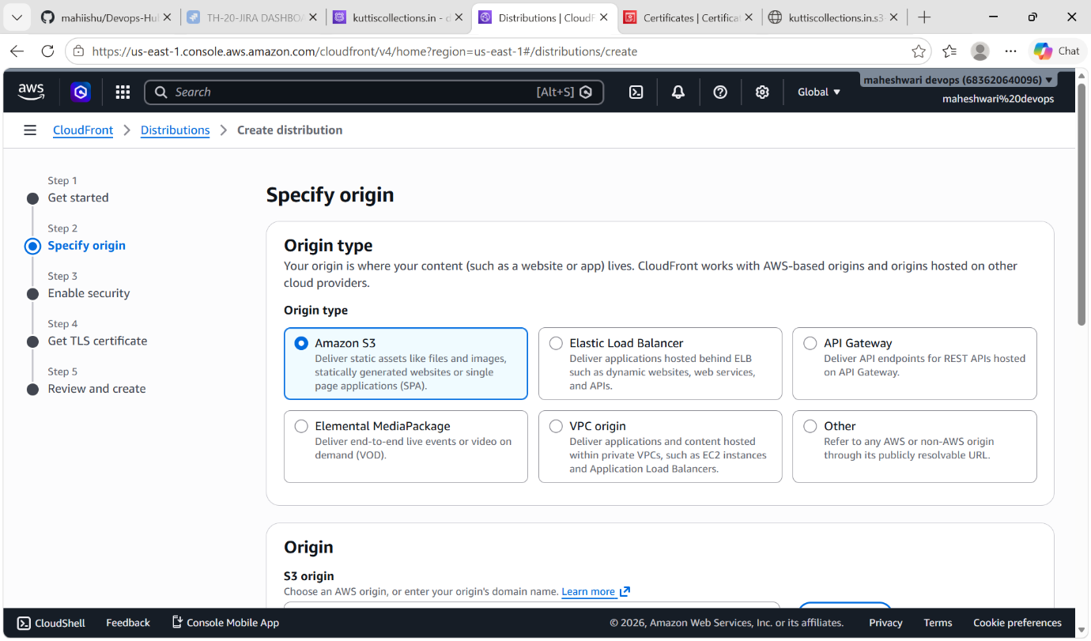

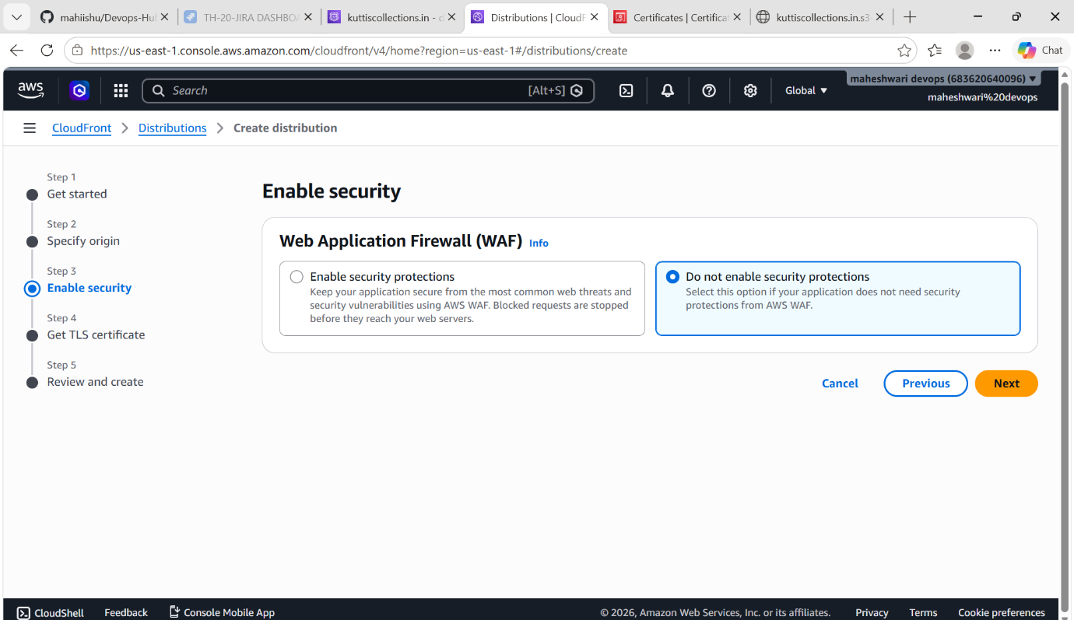

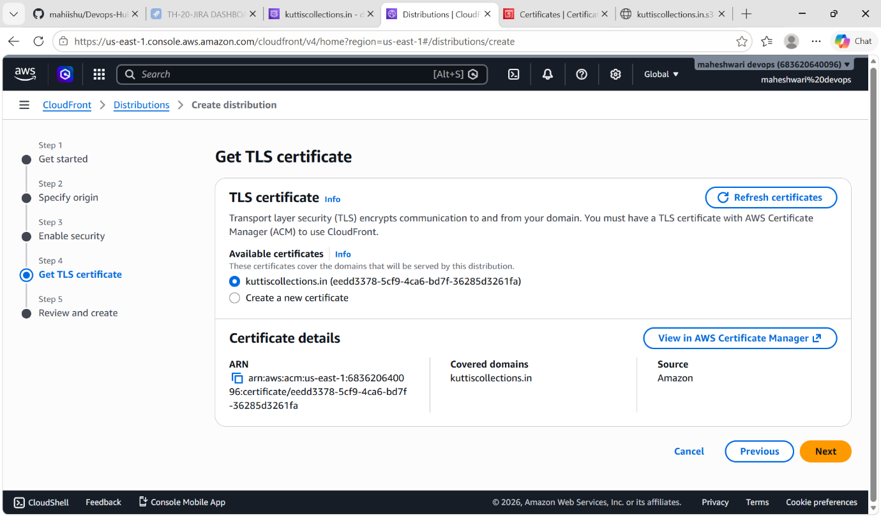

- After the cloud front distribution is created. Create a hosted zone in Route53 service.
- In hosted zone, we have to add our domain name and cloudfront distribution name.
- In CloudFront distribution only, we have to add our alternate domain name to access our website with domain name.

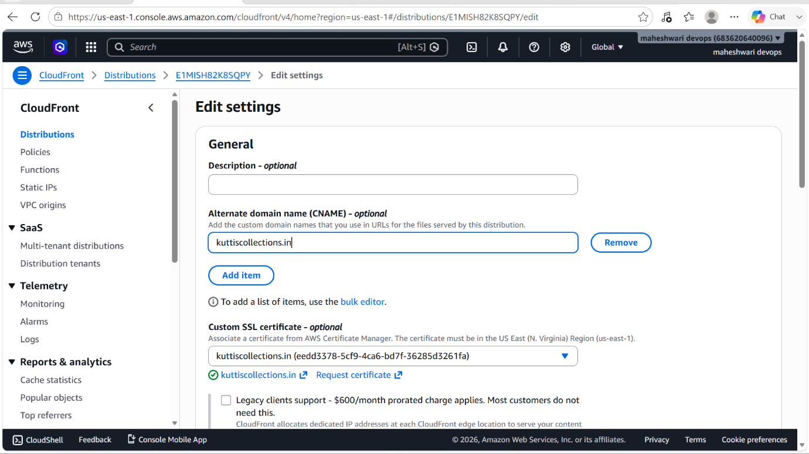

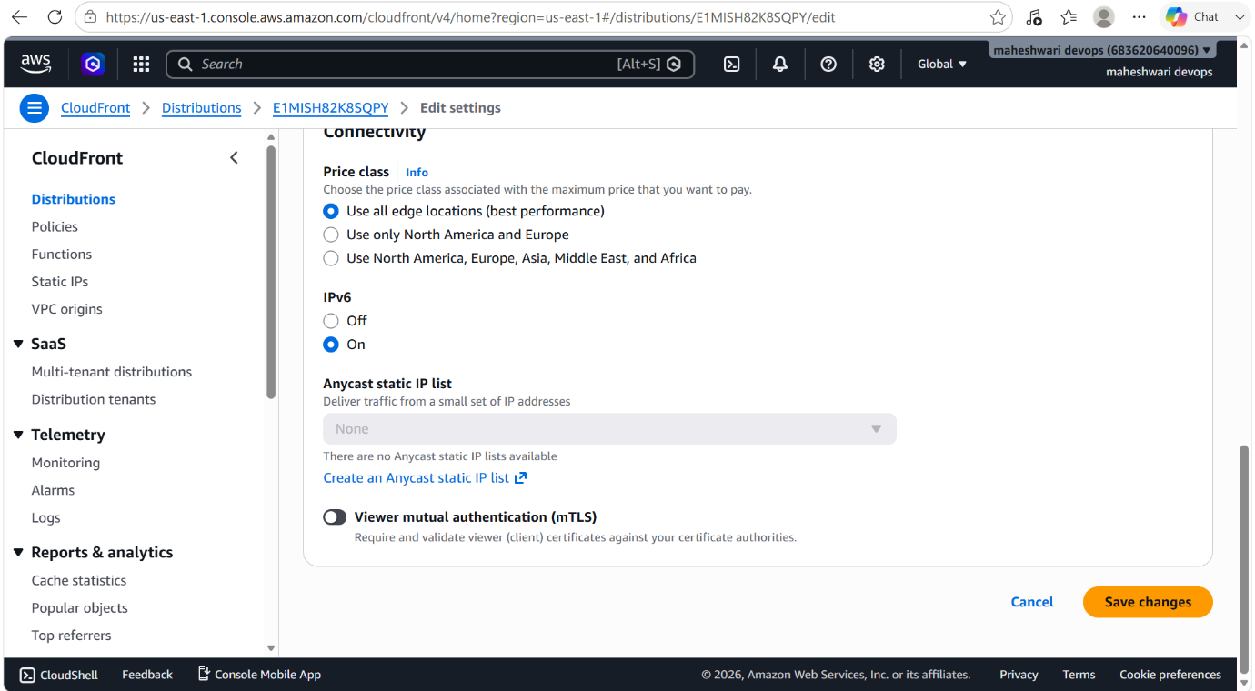
- In route53, we have to create a record to connect with the cloudfront distribution.

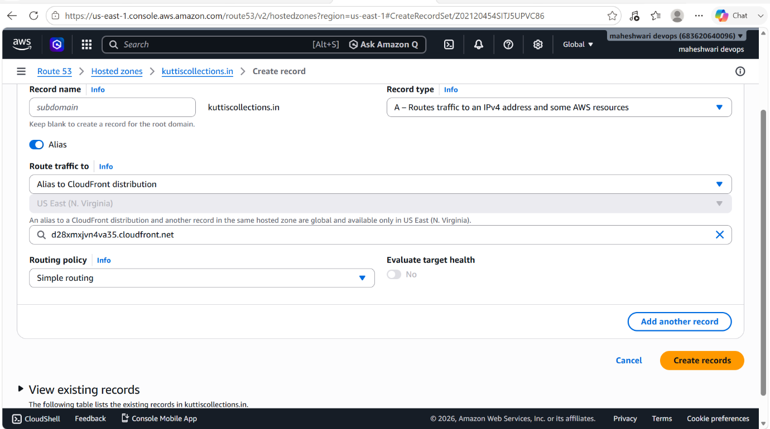

7. Update the index.html in the S3 bucket and ensure the updated file is accessible using the domain name.

PURPOSE: The purpose of updating the index.html file in the S3 bucket and verifying access through the domain name is to ensure that website content changes are successfully deployed and visible to end users through the configured domain.

OBJECTIVE: The updated index.html page should load successfully when accessed through the configured domain name, demonstrating that content updates are properly deployed and served to users.

OUTCOME: When the website is accessed using the configured domain name, the updated index.html page is displayed successfully, confirming that the content update and domain mapping are working as intended.

STEP BY STEP IMPLEMENTATION:
- Go to S3 bucket, update the index.html file with new file or edit that index.html file with the desired content that u want in the local machine using CLI.
- Then after go to CloudFront distributions, create a new validation with the /index.html.
- Then wait for distribution deployment is completed.
- Then verify that changed content with domain name.

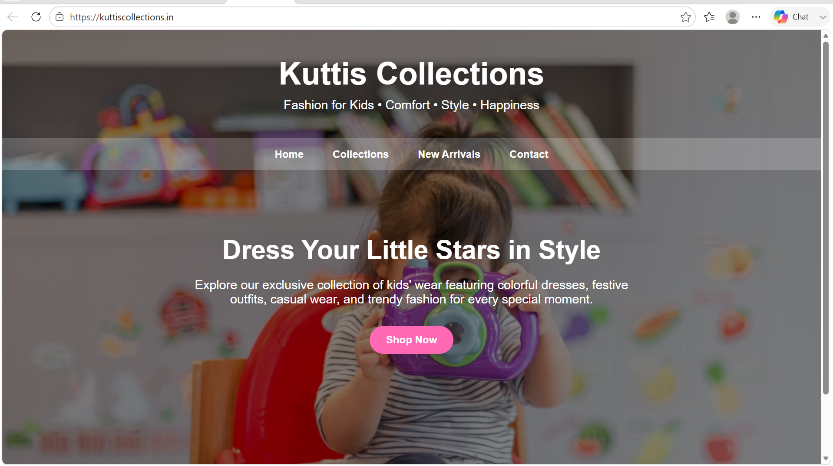

- This is the domain before changing content of the index.html file of S3 bucket.



